**Basic Linux Commands**

# 1) pwd

**Function:** Print the current working directory.

Syntax: pwd

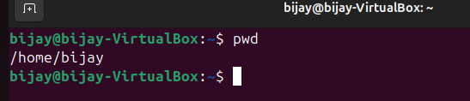

# 2) cd

**Function:** Change the current directory.

Syntax: cd [directory]

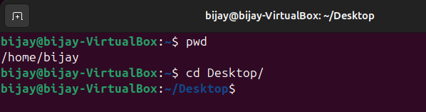

# 3) ls

**Function:** List the files and directories in the current directory.

Syntax: ls [options] [directory]

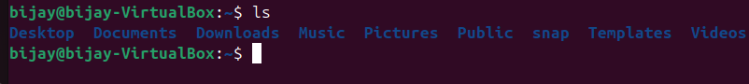

# 4) ls -all

**Function:** List the files and directories in the current directory.

Syntax: ls -all

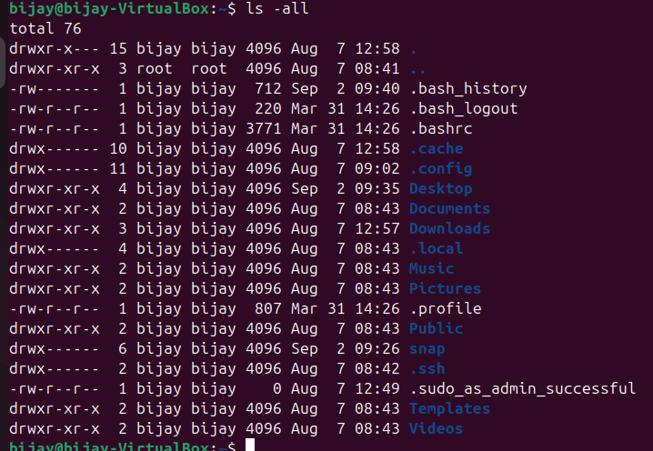

# 5) mkdir

**Function:** Create a new directory.

Syntax: mkdir [options] directory



# 6) touch

Function**:** Create an empty file or update the timestamp of an existing file. Syntax: touch [options] file



# 7) chmod

**Function:** Change the permissions of a file or directory. Set permissions to read, write, and execute for the user, and read and execute for the group and others

Syntax: chmod [permissions] file

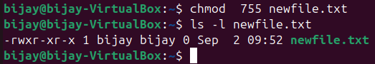

# 8) rm

**Function:** Remove a file.

Syntax: rm [options] file

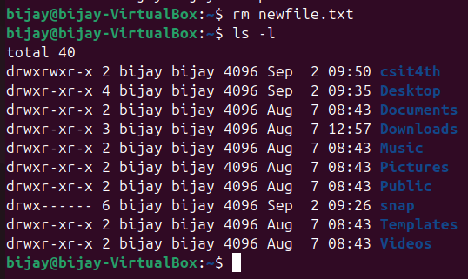

# 9). vi

Function**:** Open and edit the file using the Vim text editor. Syntax: vi file

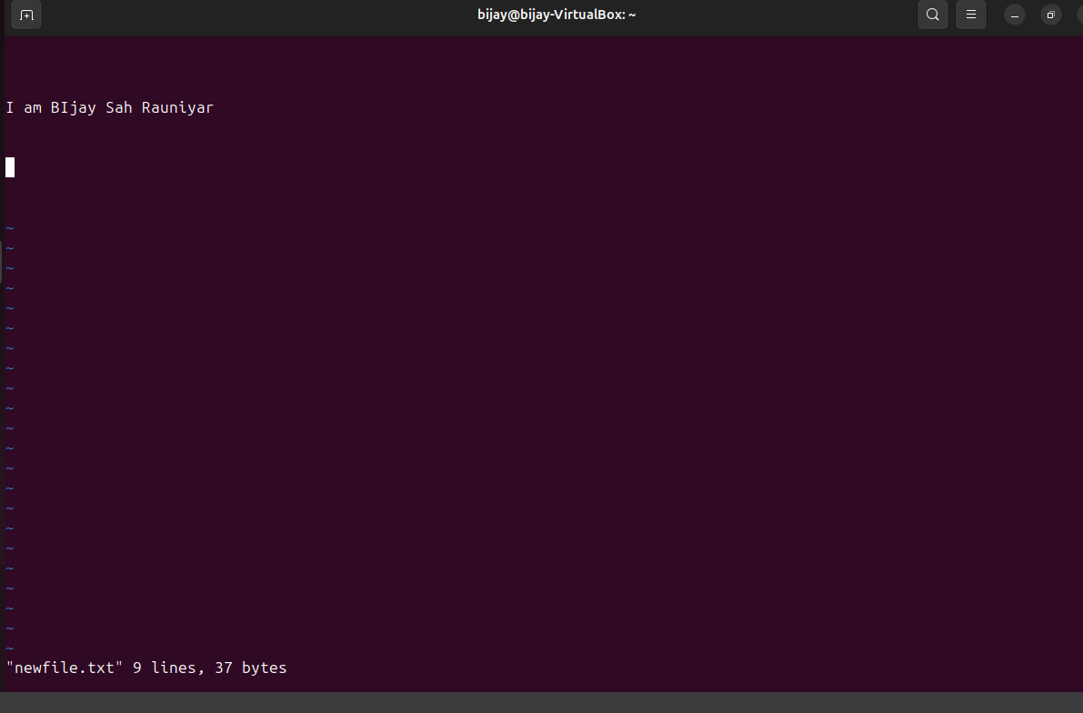

# 10). cat

**Function:** Display the content of the file.

Syntax: cat [options] file

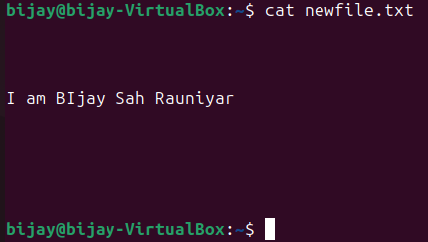

# 11). tree

Function**:** Display directory structure in a tree-like format.

Syntax: tree [options] [directory]

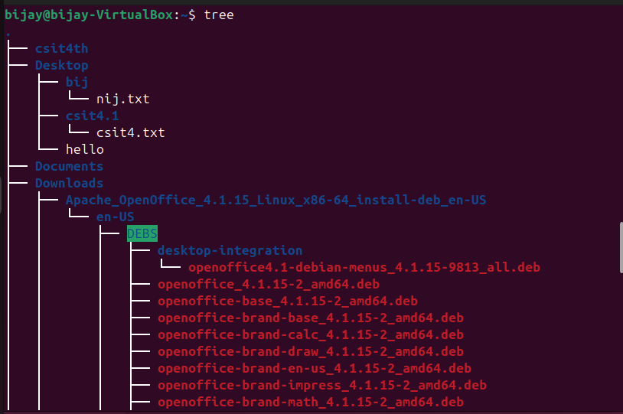

# 12) sudo apt-get install

**Function:** Install a package using the APT package manager.

Syntax: sudo apt-get install package

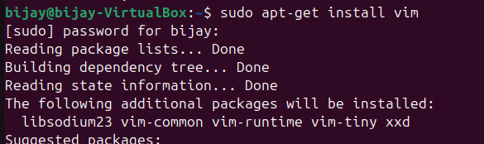

# 13) History

**Function:** Display the command history. Syntax: history

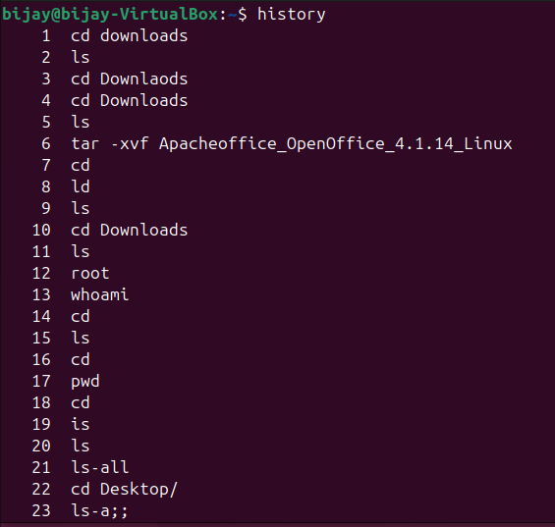

# 14) clear

**Function:** Clear the terminal screen.

Syntax: clear

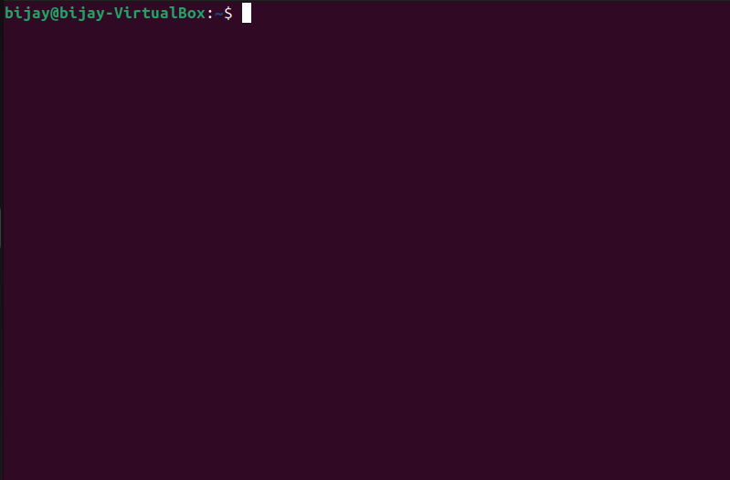

# 15) ln -s

**Function:** Create a Symbolic Link to a File

Syntax: ln -s source destination

# 16) cp

**Function:** Copies files or directories from a source to a destination. Syntax: cp [options] source destination

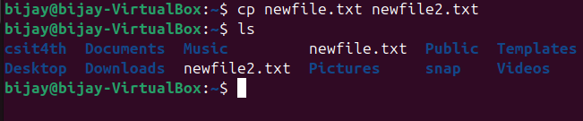

# 17) mv

Function**:** Moves files or directories from a source to a destination; can also be used to rename files or directories.

Syntax: mv [options] source destination

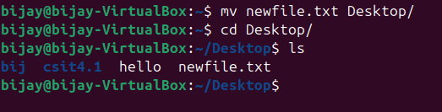

# 18) sudo useradd

**Function:** Adds a new user to the system.

Syntax: sudo useradd [options] username

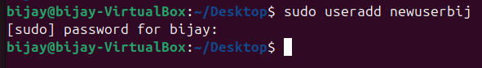

# 19) sudo passwd

**Function:** Sets or changes the password for a user.

Syntax: sudo passwd username

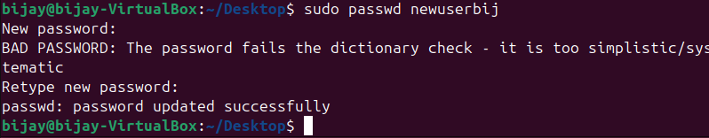

# 20) whoami

**Function:** Displays the username of the current user.

Syntax: whoami

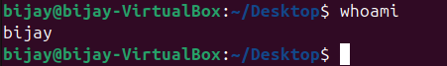

# 21) su

**Function:** Switches to a different user account.

Syntax: su username

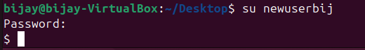

# 22) shutdown

**Function:** Shuts down or restarts the computer.

Syntax: shutdown -h [time] [message]



# 23) df

Function: Display information about disk space usage.

Syntax: df [options] [file...]

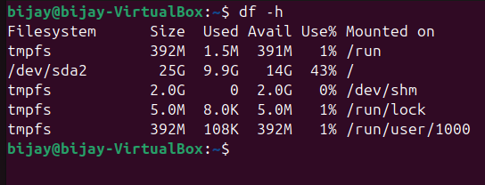

# 24) ps

Function: Display information about running processes.

Syntax: ps [options]

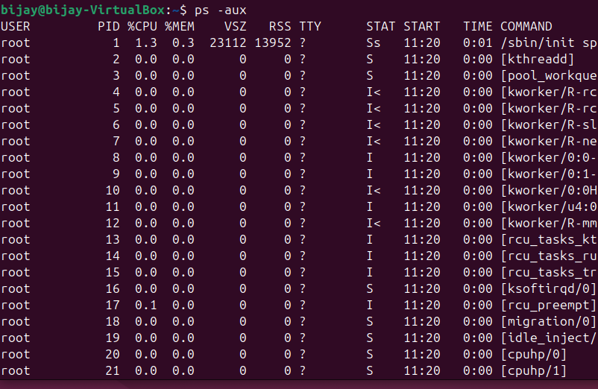

1. df -i

Function: Display the inode usage of file systems.

Syntax: df -i

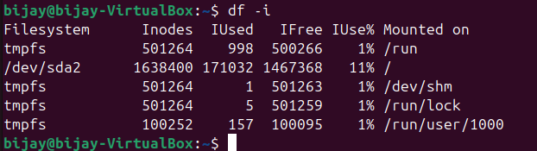

1. uname -a

# Function: Display information about the system, including the kernel version. Syntax: uname -a

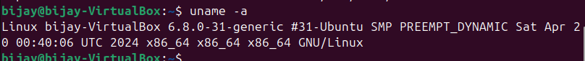

27) env

Function: Display the environment variables for the current session.

# Syntax: env

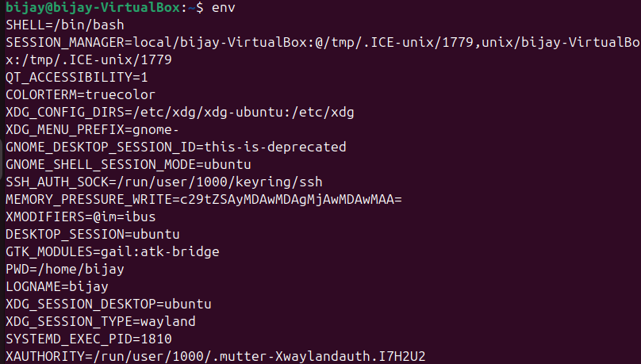

# 28) uptime

Function: Show how long the system has been running, along with the system load.

# Syntax: uptime

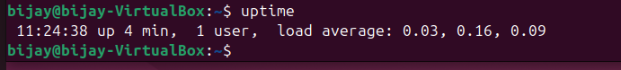

29) man

Function: Display the manual for a command.

# Syntax: man [command] Example: man ls

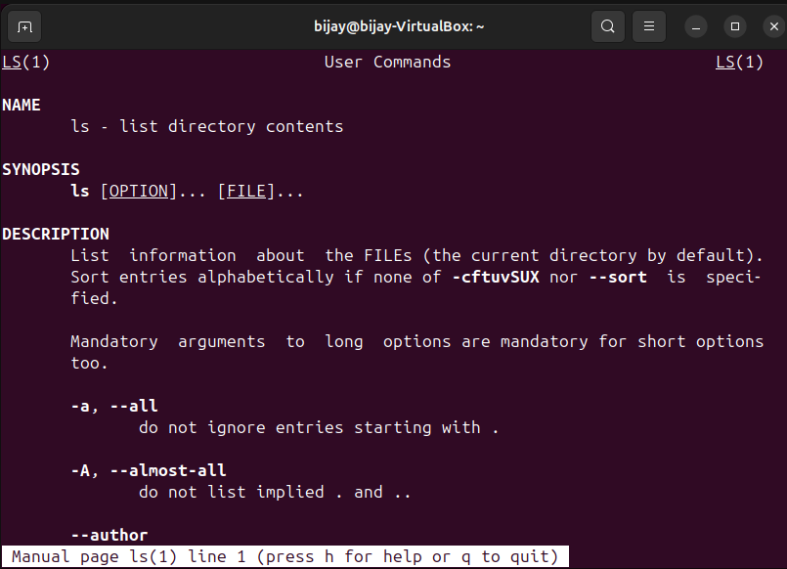

# 30) top

Function: Display real-time system processes and resource usage, such as CPU and memory usage.

# Syntax: top

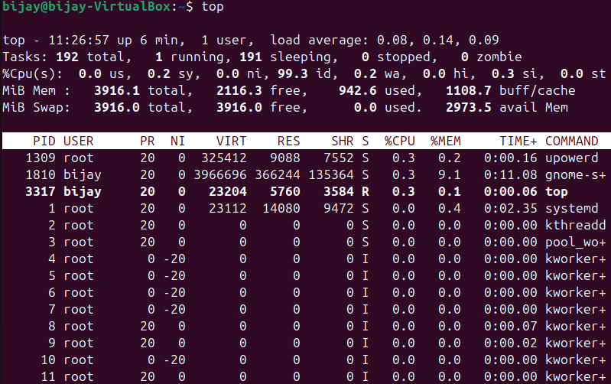

31) du

Function: Show disk usage of files and directories.

# Syntax: du [options] [directory] Example: du -sh *

